- BID Area

Grand Union BID
The BID Area is the area shown on the following plan:

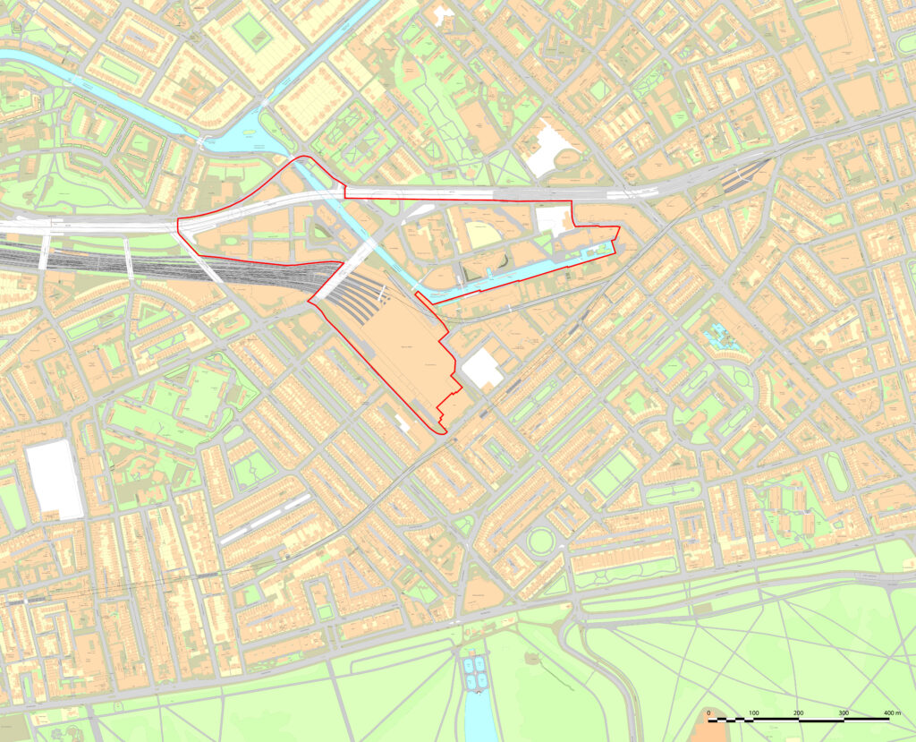

List of streets in Grand Union BID

Street | Inspection Frequency* | Street Category**
Baltic Wharf (all) | N/A | Private
Bishop’s Bridge Road (part between Eastbourne Terrace and Harrow Road) | Monthly | SR
Canalside Walk (all) | N/A | Private
Dudley Street (all) | Annual | Local Access Road
Eastbourne Terrace (odd numbers) | Monthly | SR
Harbet Road (part, 5 to 9) | Annual | E
Harrow Road (part, 89 to 181) | Monthly | SR
Hermitage Street (all) | Annual | E
Kingdom Street (all) | N/A | Private
Merchant Street (all) | N/A | Private
North Wharf Road (all) | Quarterly | B
Paddington Station (all) | N/A | Private
Rosewood Walk (all) | N/A | Private
Sheldon Square (all) | N/A | Private
Stone Wall (all) | N/A | Private

schedule 2 - Standard Services

The Standard Services consist of:
- Cleansing Services as set out in Section 1

- Highways Services as set out in Section 2 and

- Neighbourhood Problem Solving and Community Engagement Services as set out in Section 3.

- Contact Us

Section 1 – Cleansing Services

Summary of Standard Street Cleansing Services, April 2025 |  |  | Street Sweeping |  |  |  |  | Litter Bins: Emptying & Washing |  |  |  | Footway Flushing
Street | From | To | Days covered | Min: No: daytime shifts | No: evening shifts | No: night shifts | Response time | Days covered | Min: frequency per day | Response time | Washing Frequency | Daytime schedule | Night schedule | Response time
Baltic Wharf | Entire |  | - | - | - | - | - | - | - | - | - | - | - | -
Bishop’s Bridge Road | Between Eastbourne Terrace and Harrow Road |  | Mon-Fri | 1 | - | - | 2hrs | - | - | - | - | - | - | 3hrs
Canalside Walk | Entire |  | - | - | - | - | - | - | - | - | - | - | - | -
Dudley Street | Entire |  | Mon, Wed, Fri | 1 | - | - | 2hrs | - | - | - | - | - | - | 3hrs
Eastbourne Terrace | Odd numbers |  | Mon-Fri | 1 | - | - | 2hrs | Mon-Sun | 2 | 1hr | 10 weekly | - | - | 3hrs
Harbet Road | Part, 5 to 9 |  | Mon-Fri | 1 | - | - | 2hrs | - | - | - | - | - | - | 3hrs
Harrow Road | Part, 89 to 181 |  | Mon-Sun | 1 | - | - | 2hrs | - | - | - | - | - | - | 3hrs
Hermitage Street | Entire |  | Mon, Wed, Fri | 1 | - | - | 2hrs | - | - | - | - | - | - | 3hrs
Kingdom Street | Entire |  | - | - | - | - | - | - | - | - | - | - | - | -
Merchant Street | Entire |  | - | - | - | - | - | - | - | - | - | - | - | -
North Wharf Road | Entire |  | Mon-Fri | 1 | - | - | 2hrs | - | - | - | - | - | - | 3hrs
Paddington Station | Entire |  | - | - | - | - | - | - | - | - | - | - | - | -
Rosewood Walk | Entire |  | - | - | - | - | - | - | - | - | - | - | - | -
Sheldon Square | Entire |  | - | - | - | - | - | - | - | - | - | - | - | -
Stone Wall | Entire |  | - | - | - | - | - | - | - | - | - | - | - | -

Summary of Standard Waste & Recycling Collection Services, April 2025 |  |  | Waste Collection |  |  |  | Recycling Collection
Street | From | To | Mon-Fri | Sat | Sun | Remedial time | Mon-Fri | Sat | Sun | Remedial time
Baltic Wharf | Entire |  | - | - | - | - | - | - | - | -
Bishop’s Bridge Road | Between Eastbourne Terrace and Harrow Road |  | Mon, Wed, Fri  07:00-12:00 | - | - | 3hrs | Wed  08:00-14:00 | - | - | 3hrs
Canalside Walk | Entire |  | - | - | - | - | - | - | - | -
Dudley Street | Entire |  | - | - | - | - | - | - | - | -
Eastbourne Terrace | Odd numbers |  | - | - | - | - | - | - | - | -
Harbet Road | Part, 5 to 9 |  | - | - | - | - | Thu  08:00-14:00 | - | - | 3hrs
Harrow Road | Part, 89 to 181 |  | 00:00-01:00  09:00-10:00  18:30-19:30 | 00:00-01:00  09:00-10:00  18:30-19:30 | 00:00-01:00  09:00-10:00  18:30-19:30 | 3hrs | 09:00-10:00  18:30-19:30 | 18:30-19:30 | 18:30-19:30 | 3hrs
Hermitage Street | Entire |  | Mon, Wed, Fri  06:00-12:00 | - | - | 3hrs | Thu  08:00-14:00 | - | - | 3hrs
Kingdom Street | Entire |  | - | - | - | - | - | - | - | -
Merchant Street | Entire |  | - | - | - | - | - | - | - | -
North Wharf Road | Entire |  | 10:00-12:00 | 10:00-12:00 | 10:00-12:00 | 3hrs | 10:00-12:00 | 10:00-12:00 | 10:00-12:00 | 3hrs
Paddington Station | Entire |  | - | - | - | - | - | - | - | -
Rosewood Walk | Entire |  | - | - | - | - | - | - | - | -
Sheldon Square | Entire |  | - | - | - | - | Thu  08:00-14:00 | - | - | 3hrs
Stone Wall | Entire |  | - | - | - | - | - | - | - | -

Section 2 Highways Services

 | Headings
 | Non Confirm Issues
SR /A1 / A2 / B | Major Streets
C / D / E | Minor Streets
 | Priority / P1
 | Non Priority / P2
 | Non Priority / P3
Non Priority / P4
Non Priority / P5
Highways
Defect Priority | Response time | Action to be taken
1 | 2 hours | Make Safe or Repair
2 | 48 hours | Make safe or Repair
3 | 14 days | Repair
4 | 28 days | Repair
5 | Programmed works | Repair (Planned works)
Lighting
Defect Priority | Response time | Action to be taken
1 | 2 hours | Make Safe or Repair
2 | 48 hours | Make safe or Repair
3 | 14 days | Repair
4 | 28 days | Repair
5 | Programmed works | Repair (Planned works)

Definitions
* Inspection Frequency: denotes the timescale of how much each street is inspected. We currently have monthly, quarterly, 6 monthly and annual inspections that are carried out for each street. The related frequency for each street has been carefully selected as appropriate based on historical volume of enquiries and defects both reported and raised, footfall, key notes of interest such as schools and care homes, functionality, location and type of street.

** Street Category: denotes the type of street it falls under. This consists of the following:

Carriageway Hierarchy

- SR – Borough Principal Road Network
- A1 – Prestige
- A2 – Special Streets
- B – Very High Traffic volume, Essential services, Major Traffic generators, Very high cyclist volume, resilient network, major bus route, high HGV usage
- C – High Traffic volume, medium traffic generators, high cyclist volume, resilient network, Minor bus route
- D – Medium traffic volume, minor traffic generators, medium cyclist volume, infrequent bus route, medium HGV usage,
- E – Low traffic volume, no traffic generator, low cyclist volume

Footway Hierarchy

- A1 – Prestige
- A2 – Special Streets
- B – Very high pedestrian volume, Essential Services, Major Traffic generators, Major bus route
- C - High pedestrian volume, medium traffic generators, Vulnerable users, Shared use, Minor bus route
- D – Medium pedestrian volume, minor traffic generators, infrequent bus route
- E – Low pedestrian volume, no traffic generator

Cycleway Hierarchy

- X – Cycle superhighway network
- Y – Quietways (unsegregated cycleways)
- Z – Docking station (designated cycle hire stations and cycle stands)

All inspections are carried out by foot with ‘wall to wall’ routine inspections of the street. This means that both the left and right footway, carriageway and any additional WCC maintained assets on the streets are inspected.

Streets are prioritised based on the street category (as detailed above). The street re-classification process is reviewed based on a number of variables, namely number of reported and issued defects, change in footfall, traffic flow, shopping district changes etc. If a street is deemed to have changed enough based on this details, then it will be either downgraded or upgraded as appropriate.

Category | Defect or Issue | Location | Extent | Detail / Information (Street Classification) | Priority Response
carriageway | carriageway | carriageway | carriageway | carriageway | carriageway
carriageway | pothole / spalling | Whole width | 50mm+ | SR /A1 / A2 / B | 1
carriageway | pothole / spalling | Whole width | 100mm + | SR /A1 / A2 / B | 1
carriageway | pothole / spalling | whole width | 20mm-49mm | C / D / E | 4
carriageway | pothole / spalling | whole width | 50mm-99mm | C / D / E | 3
carriageway | pothole / spalling | whole width | 100mm + | C / D / E | 1
carriageway | rutting | whole width | 20mm+ | Any street | 4
carriageway | crowning | whole width | 50mm + | Any street | 4
carriageway | depression | whole width | 50mm + | Any Street | 4
carriageway | pedestrian crossing | whole width | ≥ 20mm | Any street | 2
carriageway | missing / defective anti skid | whole width | yes | Any street | 4
footway | pothole / "bubbled" mastic / uneven surface/concrete fillet (gap or missing) | whole width | 50mm+ | Any street | 1
footway | pothole / "bubbled" mastic / uneven surface/concrete fillet (gap or missing) | whole width | 20mm-49mm | SR/ A1 / A2 / B | 2
footway | pothole / "bubbled" mastic / uneven surface/concrete fillet (gap or missing) | whole width | 20mm-29mm | C | 3
footway | pothole / "bubbled" mastic / uneven surface/concrete fillet (gap or missing) | whole width | 30mm+ | C | 3
footway | pothole / "bubbled" mastic / uneven surface/concrete fillet (gap or missing) | whole width | 20mm-29mm | D / E | 4
footway | pothole / "bubbled" mastic / uneven surface/concrete fillet (gap or missing) | whole width | 30mm+ | D / E | 4
footway | pothole / "bubbled" mastic / uneven surface/concrete fillet (gap or missing) | whole width | 20mm-29mm | D / E | 4
footway | tree root damage /sunken covers / coal plates etc / rocking slab or block | whole width | 20mm+ | SR/ A1 / A2 / B | 2
footway | tree root damage /sunken covers / coal plates etc / rocking slab or block | whole width | 20mm+ | C | 3
footway | tree root damage /sunken covers / coal plates etc / rocking slab or block | whole width | 20mm+ | D / E | 4
footway | open joint excluding cobbled surfaces | whole width | 20mm+ | SR/ A1 / A2 / B | 4
footway | open joint excluding cobbled surfaces | whole width | 20mm-29mm | D / E | 4
footway | open joint excluding cobbled surfaces | whole width | 30mm+ | D / E | 4
footway | open joints on cobbled | whole width | >30mm wide x 50mm deep | Any street | 3
footway | Basement flooding (water percolation) | whole width | yes | Any street | 2
kerbs | dislodged/ misaligned  (vertical displacement to be considered as footway) | whole width | 50mm lateral | Any street | 4
kerbs | dislodged/ misaligned  (vertical displacement to be considered as footway) | whole width | 75mm lateral | Any street | 3
kerbs | missing | whole width | yes | SR/ A1 / A2 / B | 2
kerbs | missing | whole width | yes | D / E | 3
kerbs | loose/rocking | whole width | yes | SR/ A1 / A2 / B | 3
kerbs | loose/rocking | whole width | yes | D / E | 4
iron works | missing cover | whole width | yes | Any street | 1
iron works | cracked/broken cover | whole width | yes | Any street | 4
iron works | worn/polished cover | whole width | yes | SR/ A1 / A2 / B | 4
iron works | leaking cover | gas leak | yes | Any street. Refer immediately to the gas company | N/A
iron works | leaking cover | other leak | yes | report to the appropriate utility company | N/A
iron works | Sunked/ raised cover | whole width | 50mm+ | Any Street | 1
iron works | Sunked/ raised cover | footway | 20mm+ | Any Street | 2
drainage | substantial standing water/flooding | whole width |  | Any street near a pedestrian crossing | 1
drainage | substantial standing water/flooding | whole width |  | SR/ A1 / A2 / B | 2
drainage | substantial standing water/flooding | whole width |  | C / D / E | 3
drainage | blocked gully | whole width | yes | Any street | 4
drainage | slow running gully | whole width |  | Any street | 4
drainage | foul smelling gully | whole width | yes | Any street | 4
drainage | broken gulley grating | whole width | whole width | Any street | 1
drainage | cracked gully grating | whole width | yes | Any street | 4
drainage | missing gully grating | whole width | yes | refer to iron works | 1
private forecourt | any hazardous defect | whole width | yes | report to owner | N/A
road markings | faded, worn or missing | Stop line | 50% loss | Any street | 3
road markings | faded, worn or missing | other markings | 50% loss | Any street | 4
non- illuminated signs | hazardous damaged / misaligned item | whole width | yes | SR/ A1 / A2 / B | 2
non- illuminated signs | hazardous damaged / misaligned item | whole width | yes | C / D / E | 3
non- illuminated signs | non-hazardous damaged / misaligned item | whole width | yes | Any street | 4
non- illuminated signs | missing/ defective/ | whole width | yes | Any street | 4
non- illuminated signs | obscured/dirty/ faded information sign | whole width | yes | Any street | 4
non- illuminated bollards | hazardous damaged / misaligned item | whole width | yes | Any street | 1
non- illuminated bollards | non-hazardous damaged/misaligned item | whole width | yes | Any street | 4
safety fences and barriers | hazardous damaged / misaligned item | whole width | yes | Any street | 2
safety fences and barriers | non-hazardous damaged/ misaligned item | whole width | yes | Any street | 4
highway general | defective/ damaged street name plate | whole width | yes | Any street | 4
highway general | defective/damaged street furniture (graffiti and flyposting) | whole width | yes | report to Transportation Commissioning | N/A
highway general | oil/diesel spillage | whole width | yes | report to Waste & Parks | N/A
highway general | presence of ice | whole width | yes | report to Waste & Parks | N/A
highway general | detritus/debris | whole width | yes | report to Waste & Parks | N/A
highway general | fly tip | whole width | yes | report to Waste & Parks | N/A
highway general | defective scaffolding | whole width | yes | report to Building Control | N/A
highway general | defective hoarding | whole width | yes | report to Highway Licensing | N/A
highway general | defective skip | whole width | yes | report to Highways Licensing | N/A
highway general | defective reinstatement | whole width | yes | report to Road Management | N/A
highway general | defective open excavation / defective / damaged utility cabinet obstruction | whole width | yes | report to appropriate utility | N/A
Item | Defect | Location | Extent | Detail / Information (Street Classification) | Priority Response
Lighting | One light out | Any | NA | Any street | 2
Lighting | Light flickering or flashing | Any | NA | Any street | 2
Lighting | Light too bright | Any | NA | Any street | 2
Lighting | Door missing | Any | NA | Any street | 1
Lighting | Wires exposed | Any | NA | Any street | 1
Lighting | Light too dim | Any | NA | Any street | 2
Lighting | Light on constantly | Any | NA | Any street | 2
Lighting | One of a pair of lamps out | Any | NA | Any street | 2
Lighting | Door loose | Any | NA | Any street | 2
Lighting | Up Lighter damaged | Any | NA | Any street | 2
Lighting | Sign out | Any | NA | Any street | 2
Lighting | Belisha Beacon out | Any | NA | Any street | 2
Lighting | Wire hanging | Any | NA | Any street | 1
Lighting | Lamppost giving electric shock | Any | NA | Any street | 1
Lighting | Hole in lamp post | Any | NA | Any street | 2
Lighting | Twisted Sign | Any | NA | Any street | 2
Lighting | Ground pit damaged | Any | NA | Any street | 1
Lighting | Lamp post knocked down | Any | NA | Any street | 1
Lighting | Damaged Lantern | Any | NA | Any street | 1
Lighting | Damaged/Missing Sign | Any | NA | Any street | 2
Lighting | Lamp loose on its post | Any | NA | Any street | 2
Lighting | Lamp post leaning slightly | Any | NA | Any street | 2
Lighting | Lamp post leaning severely | Any | NA | Any street | 1
Lighting | Damaged/Missing Bollard | Any | NA | Any street | 2
Lighting | RTC attendance | Any | NA | Any street | 1
Lighting | More than three consecutive lights out | Any | NA | Any street | 1

Objective | Performance Requirement | Response to Defects
 |  | Category 1 |  | Category 2
 |  | Hazard  Mitigation (if necessary) | Permanent Remedy | Permanent  Repair
Traffic Signs-Includes all Illuminated traffic signs, Illuminated Bollards, Belisha Becons
Signs are clearly visible at all times, clean and operational | Signs are clean, clearly visible and free from structural and electrical defects.  Identification marks are provided, correctly  located, visible, clean and legible.  Coefficient of retro reflectivity is greater than 144 cd/lx/m2 for Class 1material and 40cd/lxl/m2 for Class 2 material  Obsolete and redundant signs are removed or  replaced as appropriate  Visibility distances meet the requirements as set out in TD25  Sign information is of the correct size, location, type, and wording to meet its intended purpose and any statutory requirements  Structures supporting large signs are inspected in accordance with BD63  All structures and elements of the signing system are kept clean and have clear access provided sign lighting is fully operational | 2 hrs | 2 Working days | 10 Working days
Sign information is complete and correct
Signs are structurally and electrically sound
Lighting equipment to signs is operational and has clear access
Power supply faults are rectified expeditiously | Private cable faults to be rectified | NA | 10 Working Days | "10 Working days
 | District Network Operator supply faults are reported to the DNO and the Provider liaises with the DNO and pursues their rectification as a matter of priority. DNO has agreed Guaranteed Standards of Performance (GSOP) in which they must repair each type of fault | Reported within 1day | Within GSOP | Within GSOP
Public Lighting – includes all Public Lighting units whether mounted on columns, walls, as floodlighting
Appropriate uniform lighting is in place along the highway | or, which by virtue of incipient defects give rise to  the likelihood of unacceptable lighting quality. Such as: |  | 2 working days | 2working days
 | 3 or more consecutive outages on lighting units up  to and including 12m mounting height | 24 hrs
 | 1or more outages either side of a pedestrian crossing | NA
 | 1or more outage opposite or immediately  adjacent to a road junction | NA
 | Private supply failure to 3 or more consecutive lighting units | 24 hrs
DNO power supply  faults are rectified expeditiously | District Network Operator supply faults are reported to the DNO and the Provider liaises with the DNO and pursues their rectification as a matter of priority. DNO has agreed Guaranteed Standards of Performance (GSOP) in which they must repair each type of fault | Reported to DNO within 2days | Within GSOP | Within GSOP
Continuous safety and integrity of the lighting  system | Over the Public Lighting Network, 97% of lights  are functioning correctly at all times. | NA | 2 working days | 2 working days
 | Lanterns are clean | NA
 | Lighting units are free from accidental damage or vandalism | 2 hrs
 | Columns are vertical. Correctly founded, visually acceptable and structurally sound | 2 hrs
Explanatory notes
The tables in this section reflect the investigation criteria and response times operated by the City Council. These are dictated by the City Council's Risk Register which assesses the impact of any defect against the likelihood of danger arising from it. This allows the Council to prioritise the spending of available funds effectively.
Highways Services comprise highway maintenance services and highway lighting services.
Highway Maintenance Service
This includes maintenance falling within the following description:
- Reactive: responding to inspections, complaints or emergencies
- Routine: regular consistent schedule for patching, cleaning, landscape maintenance and other activities
- Programmed: planned schemes, primarily of resurfacing, reconditioning or reconstruction
- Regulatory: inspecting and regulating the activities of others
Reactive Maintenance
The requirement for reactive maintenance can arise in one of two ways:
1. A customer calls the Environment Action Line and reports a carriageway, footway or street furniture defect. Enquiries are logged and directed through the Highway Maintenance software (Confirm) to the Service Providers. Urgent enquiries are attended within 2 hours of the enquiry. Non urgent enquiries are inspected by the Road Management team and a job is raised with our Service Provider if required.
2. A Road Management Inspector finds a defect during a programmed inspection (every publicly-maintained highway is inspected annually, six monthly, quarterly or once a month depending on priority) and orders the work.
Calls to the Service Provider are prioritised by the Highway Helpline staff based on criteria provided by the city council’s Highways and Public Realm service. The action taken depends on the criteria below:
Category 1 defects (response in or under 48 hours) - these are defects which are deemed to represent an immediate danger to the public or which could result in significant damage to property. Category 1 defects are sub-divided into:
- Priority 1- 2 hours to make safe
- Priority 2 - 48 hours to make safe or repair
Category 2 defects (response in excess of 48 hours) - these are defects which have a lower risk and are likely to worsen in the near future to a Category 1 defect.
Category 2 defects are sub-divided into:
- Priority 3 - 28 days to repair
- Priority 4 - Repair during the next available programme, or schedule more detailed inspection, or review condition at next inspection (subject to budget)
Routine Maintenance
Routine maintenance includes:
- drainage systems- cleansing and repair
- fences and barriers - repair
- traffic signs and bollards - cleansing and repair
- road markings and road studs - replacement
- non-illuminated street furniture- clean and paint
- benches - clean and varnish
The frequency of routine maintenance is dependent on funding but aims to achieve the standards set out in the table below.
Routine Maintenance Activities
Work | Service Level
Road Markings (Highways) 4-yearly  - Repaint / Refresh | 4-yearly
Road Markings (Highways) 4-yearly  - Replacement | 12-yearly
Road Markings (Parking) | Yellow Lines  Zone E, F, G- refresh every year  Zones A, B, C, D, H -once every 3 years  Bay Markings  Zones E, F, G- refresh every year Zones A, B, C, D, H - once every 3 years  Kerb Blips  Refresh all 3 x times a year
Cleaning and painting of street furniture (pedestrian guard rails, barriers, signs, bollards and benches) | Benches -Annual clean and re-paint  Other street furniture- 4-yearly clean and re paint
Maintenance of gates | Annual maintenance.  Re-painting: every 3rd year
Flags and flagpoles | Three times a year wash and clean (every four months)
Drainage | - A minimum annual routine visit to each and every gully or drainage asset  - An agreed, evaluated and appraised intelligence based targeted maintenance gully programme based upon a risk management approach. Gully cleaning at a higher frequency to ‘critical locations’ and a lower frequency to other locations based upon priority and risk.

Programmed Maintenance
It is not possible to set standards for when carriageway and footway resurfacing will be undertaken as the inclusion of a scheme in the approved programme will depend on its assessed priority and on the budget available.
The City Council has adopted a Value Management process to determine which areas of footway and carriageway are to be included in the annual capital programme. This process starts in the summer of each year when an Annual Condition Survey (ACS) is carried out based on industry agreed practice. The survey results in a Condition Index (Cl) for every footway and carriageway. A high Cl means the surface is in poor condition and vice versa.
In addition to the ACS survey results, the Value Management process takes into consideration a range of factors e.g. Visual Appearance, Customer Reports and Maintenance History when deciding how to spend the budget.
The programme of schemes is subject to a Cabinet Member decision and is published on the council's website. The list of ACS survey scores, Value Management scores and provisional programme of works is typically published in April each year.
Regulatory work
This includes:
- keeping a highway register
- management of utilities- utility companies are obliged to meet the minimum standards set out in the Code of Practice published under the New Roads and Street Works Act 1991
- licenses for highway occupation
- other regulatory functions - encroachment, illegal signs, etc
Highway Lighting Service
This includes reactive maintenance, routine maintenance and a renewal and improvement programme of the stock of electrical/lit traffic signs and public lighting.
Reactive Maintenance
The system for reactive maintenance rectifies defects identified from inspections, other reports or complaints, which include the following:
- lamp change
- control gear replacement
- lantern (or part) replacement
- operational control system, (PECU, Timeclock, Remote Monitoring unit)
- circuit protection replacement I upgrade as required
- internal wiring
- doors and door locks
- paint and number as required
- safety check for electrical and structural issues
- electrical service I connections
- fitting of fault plates
- all good housekeeping work (e.g. -greasing locks, aligning sign plates, refixing doors etc)
Report It online https://www.westminster.gov.uk/report-it
or call Environmental Action Line 0207 641 2000
Routine Maintenance
The system of routine preventative maintenance includes:
- clean and check
- cyclical lamp change as required
- cyclical painting as required
- cyclical structural testing as required
- cyclical electrical testing as required
- assessment of asset condition
- all good housekeeping work (e.g. -greasing locks, aligning sign plates, refixing doors etc)
- identify any items that represent a significant deterioration from the required condition preventing an item from acting in the intended manner that maybe the result of damage or that may be likely to increase the rate of deterioration of another item or cause an unintended hazard or nuisance.
Responding to Defects
Defects identified through reactive and routine maintenance checks categorised and rectified according to the standards summarised below.
Category 1 defects are those, which require prompt attention because they represent an immediate or imminent risk to safety (2 hours).
Category 2 defects are all other defects (2 -10 working days).
Where the fault rests with the Network Operator supply, this can take up to 40 days.
Renewal and Improvements
It is not possible to set standards for when public lighting will be renewed or improved as the inclusion of a scheme in the approved programme will depend on its assessed priority and on the budge available.
Schemes are identified using the Value Management process adopted for lighting, which reviews the structural and electrical condition of street lights across the City, and by taking into account other factors such as lighting standards, crime levels and maintenance records.
The programme of schemes is subject to a Cabinet Member decision and is published on the council's website. A list of provisional programmes of works is typically published in April each year.
Highways Inspections
Streets are inspected weekly. These "wall-to-wall" inspections are carried out on foot by dedicated lighting scouts with any defects found logged through live handheld devices.

Section 3
Neighbourhood Problem Solving and Community Engagement Services

Each ward in Westminster is covered by our Neighbourhoods Service. Comprising of eight area-based teams, each with a dedicated Team Leader, Neighbourhood Coordinator and named ward city inspectors. The Hyde Park & Marylebone ward has a dedicated neighbourhood’s team as outlined below.
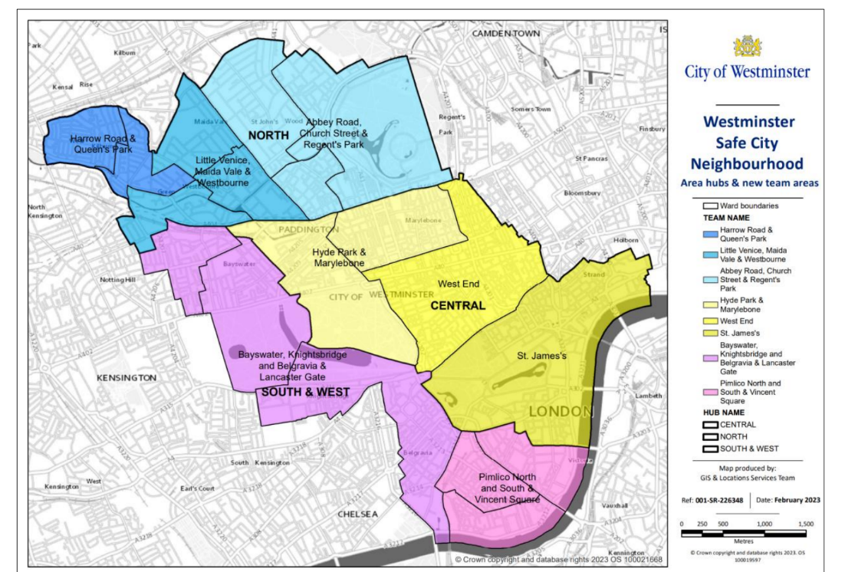

This offers a focused, localised level of support with ward-based City Inspectors and Neighbourhood Coordinators, responsible for on street management, identification of issues and resolution where they have the tools and powers to do so. Working on extended operating hours, spread between 7am through till 7pm, Monday to Friday, with additional city-wide coverage on Saturdays. The neighbourhood service will be there to speak, listen and respond to our communities.

BIDs are considered key partners to the Council and in supporting its work to problem solve, issues, achieve compliance and enforce where necessary. Therefore, the BID will be invited to relevant partnership meetings including at a minimum the regular Neighbourhood Coordination Meeting for the Ward.

The resources* allocated to the Hyde Park & Marylebone Ward, which contains the Grand Union Bid footprint are outlined below -

Team Leader x 1
Neighbourhood Coordinator x 2
Senior City Inspector x 1
City Inspectors (for Neighbourhood Team) x 5

*Whilst we endeavour to maintain a full complement of resources there may be occasions due to staff turnover or absence where numbers fall below the number of officers outlined above.

This resource will also be complemented by our 24/7 Response Service which can be tasked to tackle specific operational challenges and enhance the offer around persistent and complex issues in key areas, without taking away from the locally delivered resource. All members of the Response Service will be Local Authority Liaison Officer (LALO) trained.

Section 4

Contacting Us

Report It
Keeping our streets safe and clean is a top priority. If you experience a problem, such as noise, dumped rubbish, missed recycling or rubbish collection, or planning issues.
The quickest way to have an issue resolved is by reporting it online https://www.westminster.gov.uk/report-it
For an immediate response contact the Environmental Action Line 0207 641 2000
You can report online or through the Environmental Action Line issues/faults/defects with:
Cleansing & Waste i.e.: footway flushing, street sweeping, rubbish, litter bins, commercial waste, dirty footways/bins/streets, graffiti
Highways: i.e. roads, pavements, carriageway or footways, highways lighting, highways repairs
Neighbourhood Working & Problem Solving i.e. anti-social behaviour, environmental health issues including noise, problems with pests/food safety, health & safety, trading standards
Communication with BIDS Routine maintenance/response to defects/improvements responded to those who raised the job. Under GDPR we cannot share details of those who may have raised other enquiries. Major works programmes are circulated in advance and we will ensure that the BID are included on the all major maintenance and scheme information that is circulated monthly.

BID Benefits

The BID will bring businesses across Paddington together, achieving a unique collective impact.

- Regenerate: Curating long-term placemaking for a safe and accessible Paddington; providing practical tools for companies to assist staff, guests and visitors; equipping the district to meet evolving business expectations.
- Connect: Building on the Partnership’s successful social impact programme, scaling up activity and creating long-term, strategic community relationships; embedding social value and ESG in business operations.
- Engage: Delivering initiatives that support employee wellbeing, satisfaction and retention, attract people back to the office and celebrate Paddington’s social capital; building a strong, successful commercial ecosystem.
- Represent: Creating a statutory designation to enable Paddington's business community to form a cohesive voice.

